**Project Report**

**On**

**Operations on Continuous Time Signals**

**Course code:** CSE 248

**Course Title:** Signal and Systems

**Section:** 02

**Submitted To**

Dr. Waselul Haque Sadid

Assistant Professor

Department of computer science and engineering

East West University

**Submitted By**

Mueem Nahid Ibn Mahbub

2017-1-60-089

Rakib Ali Tanzin

2017-1-60-

MD. Jubayer Hossain Abir

2017-1-60-084

**Date of Submission:** 18 November, 2018

**Objectives:**

In this project, you have to consider an arbitrary signal and do the followings.

1. Express the signal mathematically and represent it graphically.
2. Apply shifting, reflecting and scaling operation.
3. Verify whether the signal is symmetric.
4. Find the even part and odd part of the signal.
5. Represent part 2) and 4) graphically and express mathematically

**Signal:**

In electrical engineering, the fundamental quality of representing some information is called signal. It does not matter what the information is i-e: Analog or digital information. In mathematics, a signal is a function that conveys some information. In fact, any quantity measurable through time over space or any higher dimension can be taken as a signal. A signal can be in form and any dimension.

**Our selected signal:**

**Mathematical Expression:**

$$x\left(t\right)=\left\{\begin{aligned}{t+4 , -4≤t≤-3 \atop 1 , -3<t≤-2 } \\ {t+3 , -2<t≤-1 \atop t+3, -1<t≤0} \\ {-2t+3 , 0<t≤1 \atop \begin{aligned}-2t+3, 1<t≤2 \\ -1, 2<t≤3 \\ t-4, 3<t ≤ 4\end{aligned}}\end{aligned}\right.$$

**Graphical representation:** 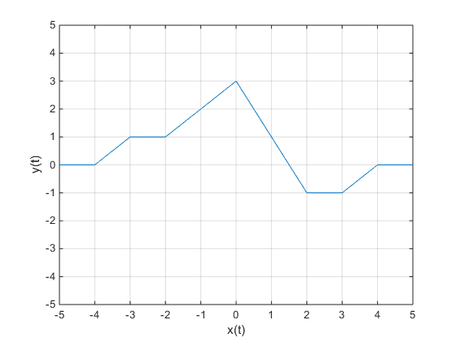

**Matlab Source code:**

t=-8:0.001:8;

x=zeros(size(t));

t1= t>=-4 & t<=-3;

x(t1)=t(t1)+4;

t2= t>-3 & t<=-2;

x(t2) = 1;

t3 = t>-2 & t<=-1;

x(t3) = t(t3)+3;

t4 = t>-1 & t<=0;

x(t4) = t(t4)+3;

t5 = t>0 & t<=1;

x(t5) = -2*t(t5)+3;

t6 = t>1 & t<=2;

x(t6) = -2*t(t6)+3;

t7 = t>2 & t<=3;

x(t7)=-1;

t8=t>3 &t <=4;

x(t8)=t(t8)-4;

plot(t,x);

xlim([-5 5]);

ylim([-5 5]);

xlabel(‘x(t)’);

ylabel(‘y(t)’);

grid on;

**Shifting:**

**Mathematical expression :**

$$x\left(t+2\right)=\left\{\begin{aligned}{t+6 , -6≤t≤-5 \atop 1 , -5<t≤-4 } \\ {t+5 , -4<t≤-3 \atop t+5, -3<t≤-2} \\ {-2t+1 , -2<t≤-1 \atop \begin{aligned}-2t+1, -1<t≤0 \\ -1, 0<t≤1 \\ t-2, 1<t ≤ 2\end{aligned}}\end{aligned}\right.$$

**Graphical representation:** 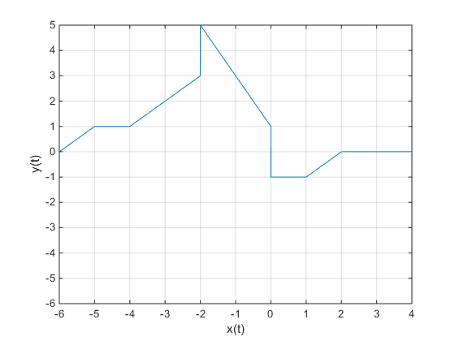

**Matlab Source Code:**

t=-8:0.001:8;

x=zeros(size(t));

t1= t>=-6 & t<=-5;

x(t1)=t(t1)+6;

t2= t>-5 & t<=-4;

x(t2) = 1;

t3 = t>-4 & t<=-3;

x(t3) = t(t3)+5;

t4 = t>-3 & t<=-2;

x(t4) = t(t4)+5;

t5 = t>-2 & t<=-1;

x(t5) = -2*t(t5)+1;

t6 = t>-1 & t<=0;

x(t6) = -2*t(t6)+1;

t7 = t>0 & t<=1;

x(t7)=-1;

t8=t>1 &t <=2;

x(t8)=t(t8)-2;

plot(t,x);

xlim([-6 4]);

ylim([-6 5]);

xlabel(‘x(t)’);

ylabel(‘y(t)’);

grid on;

**Reflection:**

**Mathematical Expression:**

$$x\left(-t\right)=\left\{\begin{aligned}{-t-4 , -4≤t≤-3 \atop -1 , -3<t≤-2 } \\ {2t+3 , -2<t≤-1 \atop 2t+3 , -1<t≤0} \\ {-t+3 , 0<t≤1 \atop \begin{aligned}-t+3 , 1<t≤2 \\ 1, 2<t ≤3 \\ - t+4, 3<t ≤4\end{aligned}}\end{aligned}\right.$$

**Graphical representation:** 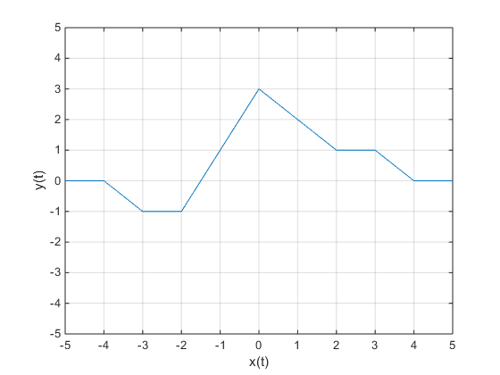

**Matlab Source Code:**

t=-8:0.001:8;

x=zeros(size(t));

t1= t>=-4 & t<=-3;

x(t1)=-t(t1)-4;

t2= t>-3 & t<=-2;

x(t2) = -1

t3 = t>-2 & t<=-1;

x(t3) = 2*t(t3)+3;

t4 = t>-1 & t<=0;

x(t4) = 2*t(t4)+3;

t5 = t>0 & t<=1;

x(t5) = -t(t5)+3;

t6 = t>1 & t<=2;

x(t6) = -t(t6)+3;

t7 = t>2 & t<=3;

x(t7)=1;

t8=t>3 &t <=4;

x(t8)=-t(t8)+4;

plot(t,x);

xlim([-5 5]);

ylim([-5 5]);

xlabel(‘x(t)’);

ylabel(‘y(t)’);

grid on;

**Scaling:**

**Mathematical Expression:**

$$x\left(2t\right)=\left\{\begin{aligned}{2t+4 , -2≤t≤-\frac{3}{2} \atop 1 , -\frac{3}{2}<t≤-1 } \\ {2t+3 , -1<t≤-\frac{1}{2} \atop 2t+3 , -\frac{1}{2}<t≤0} \\ {-4t+3 , 0<t ≤\frac{1}{2} \atop \begin{aligned}-4t+3 , \frac{1}{2}<t≤1 \\ -1, 1<t ≤\frac{3}{2} \\ 2t-4, \frac{3}{2}<t ≤2\end{aligned}}\end{aligned}\right.$$

**Graphical Representation:** 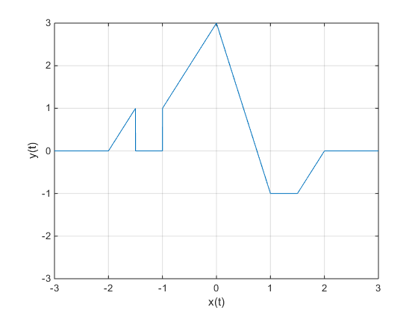

**Matlab Source Code:**

t=-8:0.001:8;

x=zeros(size(t));

t1= t>=-2 & t<=-3/2;

x(t1)=2*t(t1)+4;

t2= t>-3/2 & t<=-2;

x(t2) = 1;

t3 = t>-1 & t<=-1/2;

x(t3) = 2*t(t3)+3;

t4 = t>-1/2 & t<=0;

x(t4) = 2*t(t4)+3;

t5 = t>0 & t<=1/2;

x(t5) = -4*t(t5)+3;

t6 = t>1/2 & t<=1;

x(t6) = -4*t(t6)+3;

t7 = t>1 & t<=3/2;

x(t7)=-1;

t8=t>3/2 &t <=2;

x(t8)=2*t(t8)-4;

plot(t,x);

xlim([-3 3]);

ylim([-3 3]);

xlabel(‘x(t)’);

ylabel(‘y(t)’);

grid on;

**Symmetric:**

**x(t)**



**x(-t)**



**Even Symmetric**

**x(-t)**



**-x(t)**

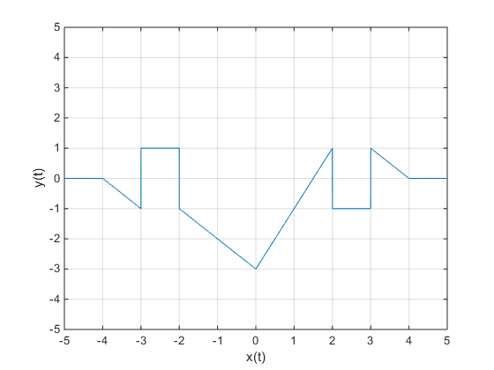

**Odd Symmetric**

Here,

x(-t) ≠ x(t)

So, the signal is not even symmetric.

Again,

x(-t) ≠ -x(t)

So, the signal is not odd symmetric.

**Even Part:**

For even part xe(t) =[x(t)+x(-t)]/2

$$Xe(t)=\left\{\begin{aligned}\frac{3t}{2}+3 , -2≤t≤1 \\ \frac{3t}{2}+3 , -1<t≤0 \\ -\frac{3t}{2}+3 , -0≤t≤1 \\ -\frac{3t}{2}+3 , 1≤t≤2\end{aligned}\right.$$

**Graphical Representation:** 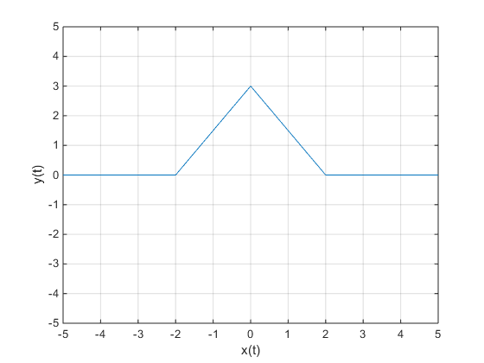

**Matlab Source Code**:

t=-8:0.001:8;

x=zeros(size(t));

t1= t>=-2 & t<=-1;

x(t1)=3*t(t1)/2+3;

t2= t>-1 & t<=0;

x(t2) = 3*t(t2)/2+3;

t3 = t>0 & t<=1;

x(t3) = -3*t(t3)/2+3;

t4 = t>1 & t<=2;

x(t4) =-3*t(t4)/2+3;

plot(t,x);

xlim([-5 5]);

ylim([-5 5]);

xlabel(‘x(t)’);

ylabel(‘y(t)’);

grid on;

**Odd Part:**

For even part xo(t) =[x(t)-x(-t)]/2

**Mathematical Expression:**

$$Xo(t)=\left\{\begin{aligned}{t+4 , -4≤t≤-3 \atop 1 , -3<t≤-2} \\ {-\frac{t}{2} , -2<t≤-1 \atop -\frac{t}{2} , -1<t≤0 } \\ -\frac{t}{2} , 0<t≤1 \\ -\frac{t}{2} , 1<t≤2 \\ -1 , 2<t≤3 \\ t-4 , 3≤t≤4\end{aligned}\right.$$

**Graphical Representation:** 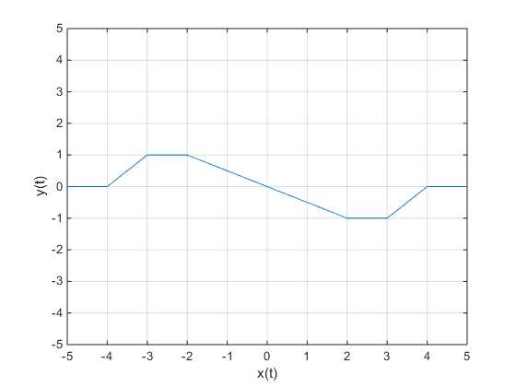

**Matlab Source Code:**

t=-8:0.001:8;

x=zeros(size(t));

t1= t>=-4 & t<=-3;

x(t1)=t(t1)+4;

t2= t>-3 & t<=-2;

x(t2) = 1;

t3 = t>-2 & t<=-1;

x(t3) = -t(t3)/2;

t4 = t>-1 & t<=0;

x(t4) = -t(t4)/2;

t5 = t>0 & t<=1;

x(t5) = -t(t5)/2;

t6 = t>1 & t<=2;

x(t6) = -t(t6)/2;

t7 = t>2 & t<=3;

x(t7)=-1;

t8=t>3 &t <=4;

x(t8)=t(t8)-4;

plot(t,x);

xlim([-5 5]);

ylim([-5 5]);

xlabel(‘x(t)’);

ylabel(‘y(t)’);

grid on;